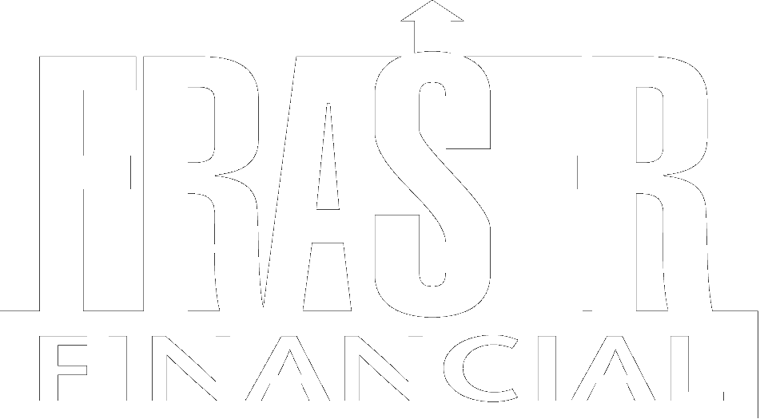

Privacy Policy

Fraser Financial has adopted the following privacy policy. It is designed to protect the information that you have entrusted to us. We hold all personal information in the strictest confidence as a part of our efforts to put our customers first. We recognize and respect our responsibility to protect this information from all unauthorized use. These records include all personal information that we collect from you in connection with any services we provide. We have not discussed your information with any nonaffiliated third parties, except as permitted by law and we do not anticipate doing so in the future. If we were to revise our policy, we are prohibited under law from doing so without advising you first. Our policy with respect to personal information about you is outlined below.

- In the process of carrying out a client engagement, the information we collect will vary depending on the scope of the engagement. It may include such items as your personal income, expenses, assets, liabilities, information regarding your health as it relates to the planning process and information about transactions between you and varied third parties.
- We limit access to client information on a “need to know” basis only. We do not share nonpublic personal information with nonaffiliated third parties except as permitted by law or as directed by you. We may, at times, find it necessary to contact third parties in order to acquire financial information about you; for example to contact your lawyer or CPA. We would do this only after contacting you and obtaining your permission.
- We maintain physical, electronic and procedural security safeguards in our office environment to assure that your information is not placed at unreasonable risk.
- Federal and state regulators may require a review of our records as permitted under law.
- We do not sell your nonpublic personal information to third parties.
- Personally identifiable information about you will be maintained during the time you are a client, and for the required time thereafter that such records are required to be maintained by federal and state securities laws, and consistent with the CFP Board Code of Ethics and Professional Responsibility. After the required period of record retention, all such information will be destroyed.
- The amount of nonpublic personal information that we collect about you will include only that necessary to complete the services you request.

If you have any questions about the privacy policy as stated above, please do not hesitate to call us at 404-351-6976.

Fraser Financial
January, 2005

